**THE NATURAL SCIENCE COLLECTIONS FACILITY**

**An Overview**

Michelle Hamer (M.Hamer@sanbi.org.za), March 2017

**(1) Background**

The Natural Science Collections Facility (NSCF) has been selected for implementation as part of the Department of Science & Technology’s (DST) South Africa’s Research Infrastructure Roadmap (SARIR) project. The South African National Biodiversity Institute (SANBI) will host the NSCF and a three-year Agreement between SANBI and the DST has been signed, but SARIR is considered as a long-term programme with projects funded for up to 15 years. The budget allocation for the NSCF for the first three years is R51.6 million.

**(2) Summary of the NSCF**

The NSCF will comprise a distributed network of institutions that hold natural science collections (preserved plant, animal, fossil, geology and fungi collections), with a Central Co-ordinating Hub which will be hosted at SANBI in Pretoria (Figure 1). SANBI will be responsible for the overall implementation of the project plan and management of the budget allocation for the NSCF from the DST. The individual institutions will continue to be supported by their existing structures, whether these are government (local, provincial or national), science councils or higher education institutions and will continue to report to these structures but will collaborate to meet the objectives of the NSCF, and will receive support in order to enable this. In the first phase of the NSCF those institutions that have dedicated collections-based staff and that allow open use of the collections and data for research purposes have been included. It is anticipated that once established, the NSCF will increase participation beyond this scope.

The establishment and implementation of the NSCF will be managed by a Lead, supported by a Project Manager. The Co-ordinating Hub will include these two staff, as well as three Working Group Co-ordinators (Curation, Data, and Outreach / Marketing), two Database Specialists and an Administrative Officer. A Co-ordinating Committee, chaired by the NSCF Lead, will include the Working Group Co-ordinators, and representatives from participating institutions, and will be responsible for implementation of the NSCF Business Plan. A fourth Working Group, for

Research, will be chaired by the NSCF Lead, and will receive input on research priorities and innovations from an annual Research Indaba. A range of stakeholders will be represented on the Advisory Committee (including but not limited to the NSCF Lead, two representatives of collections sector, DST, Department of Arts & Culture, Department of Environmental Affairs, Department of Agriculture, Forestry & Fisheries, Eastern Cape Department of Sport, Recreation, Arts & Culture, SANBI (CEO or delegate to chair) which will advise on NSCF plans, approaches and collaborations. *Ad hoc* advisory sessions will be organised to get input from experts in various aspects of collections and associated research. Participation by institutions in the NSCF will be through the signing of an Memorandum of Understanding (MoU) with SANBI and where funds are transferred from SANBI to the institution, a Collaboration Agreement will be signed.

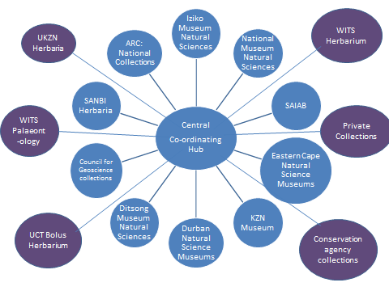

**Figure 1. The structural model for the NSCF. The Central Co-ordinating Hub will be hosted by SANBI in Pretoria.**

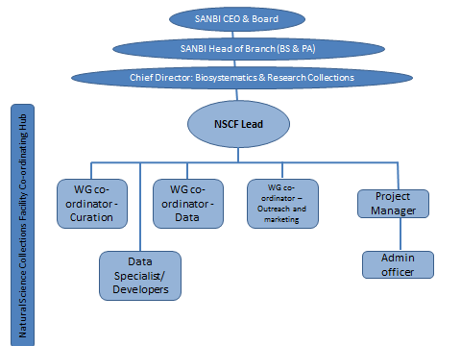

**Figure 2. Organogram of the NSCF Co-ordinating Hub which will be based at SANBI.**

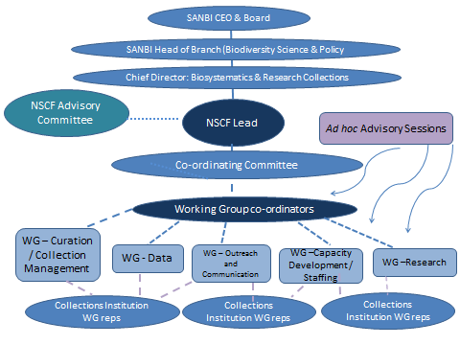

**Figure 3. Governance and operations of the NSCF. Dotted lines indicate participation / representation, solid lines represent reporting lines.**

**(3) Three-year project plan and budget**

The overall aim of the NSCF is to ensure that***collections and associated data are used for high quality research and decision-making to address issues of socio-economic importance***

In order to realise this aim, the NSCF has five Strategic Objectives (SOs).

* SO 1. Collections (=research infrastructure) secured and accessible physically and virtually for research
* SO 2. Data from specimens in collections accessible and used for managing collections, research and decision-making
* SO 3. Research on collections and associated data addresses issues of national and global relevance
* SO 4. Collections and associated research provide services to identify biological specimens for a range of stakeholders including in the agriculture, health, environmental management and academic sectors
* SO 5. Collections used for serving broader society through education, citizen science and public understanding projects with emphasis on inspiring young scientists and promoting South Africa’s unique biodiversity assets.

In order to achieve these objectives the following enabling strategies will be critical:

* Transform the current fragmented natural science collections landscape by establishing the NSCF with participatory planning, and collaborative implementation, monitoring and reporting processes and systems.
* Ensuring that appropriate capacity to curate collections, manage data and research the collections is available and well qualified staff are retained.
* Expanding the investment in collections and associated research.

In the next three years (2016/17-2018/19), there will be two main areas of focus:

1. establishing the NSCF, including the Co-ordinating Hub, Working Groups and governance structures and ensuring that the new approach for a single virtual Facility is operational, and developing common policies, procedures, standards and workflows across institutions, and establishing mechanisms for monitoring implementation of these; and
2. ii. promoting the Facility and highlighting the value of the collections for research, decision-making, identification services and education.

The activities and time frames are provided in Table 1.

**Table 1. Strategic Objectives, activities and timeframes for the NSCF**

|  |  |  |  |
| --- | --- | --- | --- |
|  | **NATURAL SCIENCE COLLECTIONS FACILITY: BUSINESS PLAN 2016/17-2018/19** | |  |
|  | **STRATEGIC OBJECTIVE** | **3 year Outcome / Objective** |
| **1** | ***Collections (=research infrastructure) secured and accessible physically and virtually for research*** | i. Inventory of collections on the NSCF website |
|  |  | ii. Collections that are at high risk / high priority secured/ collection facilities upgraded |
|  |  | iii. A virtual museum for global use by researchers and broader society initiated |
|  |  | iv. Tissue and DNA collections accessible for research |
|  |  | v. Common standards, procedures and monitoring programme for collections across institutions |
| **2** | ***Data from specimens in collections accessible and used for managing collections, research and decision-making*** | i. Standards, processes and workflows for data capture, verification, upgrading and integration across institutions |
|  |  | ii. Verification and upgrading of specimen data for vertebrates (mammals, birds, reptiles, fish, amphibians), fungi and two plant families |
| **3** | ***Research on collections and associated data addresses issues of national and global relevance*** | i. Large, collaborative and multidisciplinary flagship research project based on the collections and associated data: proposal |
|  |  | ii. Accelerated description of new species where these are required for improving scientific quality of collection / strategically important research activities |
|  |  | iii. Increased use of collections for research and capacity development |
|  |  | iv. Upgraded research equipment and facilities at selected collection institutions |
| **4** | ***Collections and associated research provides services to identify biological specimens for a range of stakeholders including in the agriculture, health, environmental management and academic sectors*** | i. Systems for monitoring identification services provided and for measuring impacts of this service |
| **5** | ***Increased public engagement and understanding in relation to the collections and discoveries based on these to inspire learners, students and citizen scientists and increase appreciation for South Africa’s unique biodiversity assets.*** | i. NSCF website, with pages relevant for public, with relevant information and links to virtual museum |
|  |  | ii. Outreach activities |
|  |  | iii. Develop and implement a branding and marketing strategy for the NSCF and collections |
|  | **ENABLING STRATEGIES** | |  |
| **6** | Transform the current fragmented natural science collections landscape by establishing the NSCF with participatory planning, implementation, monitoring and reporting processes and systems. | i. NSCF staff appointed: Project Manager; Co-ordinators for Curation; Data; Capacity Development; and Outreach and Communication; Administrative Assistant |
| **6.1.** | Establishing the Co-ordinating Hub and governance structures and mechanisms for planning, implementation, monitoring and reporting for the NSCF | ii. Documentation for governance and operations of NSCF Co-ordinating Hub (TORs, guidelines, processes) |
|  |  | ii. Steering Committee, with TORs for NSCF, meeting at least once per annum |
|  |  | iii. Co-ordinating Committee (managers or representatives from each participating institution) established; TORs developed; meeting on a monthly basis to finalise objectives, activities, targets and resources, to monitor progress and provide information for reporting |
|  |  | iv. Five Working Groups, with Terms of Reference (TORs), meeting at least quarterly, detailed implementation plans and reports on progress against targets. |
|  |  | vi. NSCF Co-ordinating Hub offices established (interim for 2 years, with only moveable assets purchased); initiation of the construction of the NSCF Co-ordinating Hub building (costs covered by SANBI’s infrastructure grant) |
| **6.2.** | **Changing culture to ensure that all staff support the NSCF and work towards a national rather than individual agenda** | vii. NSCF Forum (every second year, for all collection institution staff) |
|  |  | viii. Change management / leadership coaching for managers to support the development of a new culture |
|  |  | ix. Common standards and job descriptions for staff in collection institutions to professionalise collections posts |
| **7** | **Capacity development** | i. Support for postgraduate students researching the natural science collections. |
|  |  | ii. Capacity development for collections and data management staff: grants for young staff in collections to attend the international Society for the Protection of Natural History Collections (SPNHC) conference or the Taxonomic Data Working Group conference |
|  |  |  |